**CMED 6210 Infectious disease modeling  
Summer 2017  
Instructor: Joseph Wu**

**Practical 1**

*Learning outcome: To build an SIR model for epidemic simulation using R.*

In this practical, we will use R to simulate disease transmission with the SIR model:

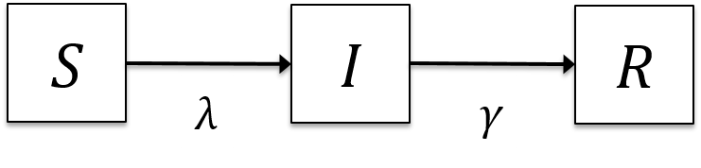

For simplicity, we assume that the disease does not cause death. *S*(*t*), *I*(*t*) and *R*(*t*) are the number of susceptible, infectious and recovered individuals at time *t*, respectively.

*λ*(*t*) is the force of infection at time *t*, i.e. the rate at each susceptible individual becomes infected.

*γ* is the rate at which infectious individuals recover.

The differential equations for the SIR model are:



For a very short time interval *Δt*, these differential equations are essentially the same as the following difference equations:



Start with the R script “deterministic_SIR_model.r”. Note that in R, lines that start with “#” are comments and will not be executed.

*Q1: Please fill in the following table.*

|  |  |  |
| --- | --- | --- |
| **Parameter** | **Variable name in the R script** | **Value assigned** |
| Basic reproductive number | R0 | 1.4 |
| Mean infectious duration | durInf | 6 days |
| Population size | N | 100,000 |
| Time step | dt | 0.1 days |
| Time horizon | tmax | 365 days |

In the SIR model, each individual makes “effective contacts” with other people in the population at a rate of

.

“Effective contacts” are (abstractly) defined as the kinds of contacts that would conduce disease transmission if such contacts are made between an infectious individual and a susceptible individual (e.g. sexual intercourse for sexually transmitted infections).

*Q2: Assume homogeneous mixing in the population. What is the rate at which effective contacts are being made between (any given) two individuals? Call this parameter .*

*Q3. What is the rate at which each infectious individual recover, i.e. γ?*

The differential and difference equations describe how *S*(*t*), *I*(*t*) and *R*(*t*) change over time. To simulate the SIR model, we need to first specify the number of susceptible, infectious and recovered individuals at the start of the epidemic, i.e. *S*(0), *I*(0) and *R*(0).

*Q4: Initialize the state variables in your R script with 100 infectious individuals and no recovered individuals.*

The SIR model is implemented in your R script using a for-loop. In each iteration of this for-loop, time is incremented from *t* by *Δt* to *t* + *Δt*.

*Q5: Calculate the force of infection at time t.*

*Q6: Calculate the number of infections and recoveries between time t and t* + *Δt within each for-loop*?

*Q7. Implement the SIR difference equations within the for-loop.*

*Q8: Plot the daily incidence over time. When does daily incidence peak? What is the peak daily incidence?*

*Q9. Plot the prevalence over time. When does prevalence peak? What is the peak prevalence?*

*Q10: How long does it take for daily incidence to drop below 1? What is the final infection attack rate at that time (i.e. cumulative incidence since the start of the epidemic)?*

*Q11: Use your R script for the SIR model to calculate the final infection attack rate for R0 ranging from 1 to 5. Plot the final infection attack rate as a function of R0.*